



From java 7









Overloading

You need to change the parameters, changing the return type only will throw a exception







































int to Integer autoboxing

Integer to int unboxing



Local Class





Abstract class implemented and non implemented methods



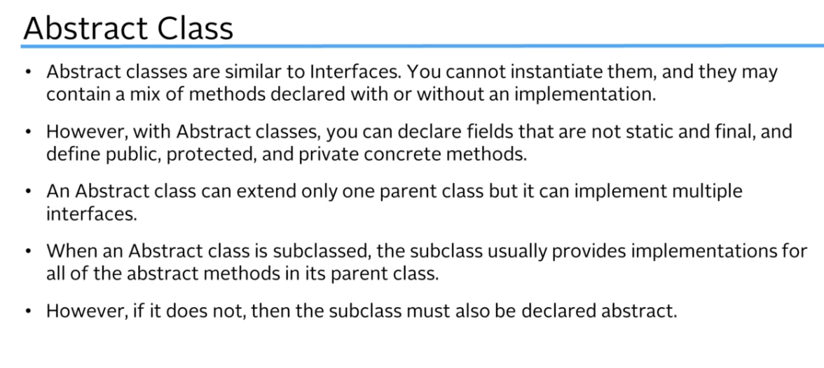







Generics









Create jar and use it



Adding a Main Class would make the jar executable (not in this case)





Now build, make project and build artifacts to generate the jar file in the location





scope



Inner class has access to the outer class variable



Final variables se pueden asignar al declarar o en el constructor

Si ya fue declarado y se asigna otra vez en el constructor marca error de compilación

Static initialization block is executed only once when the class is first loaded into the project







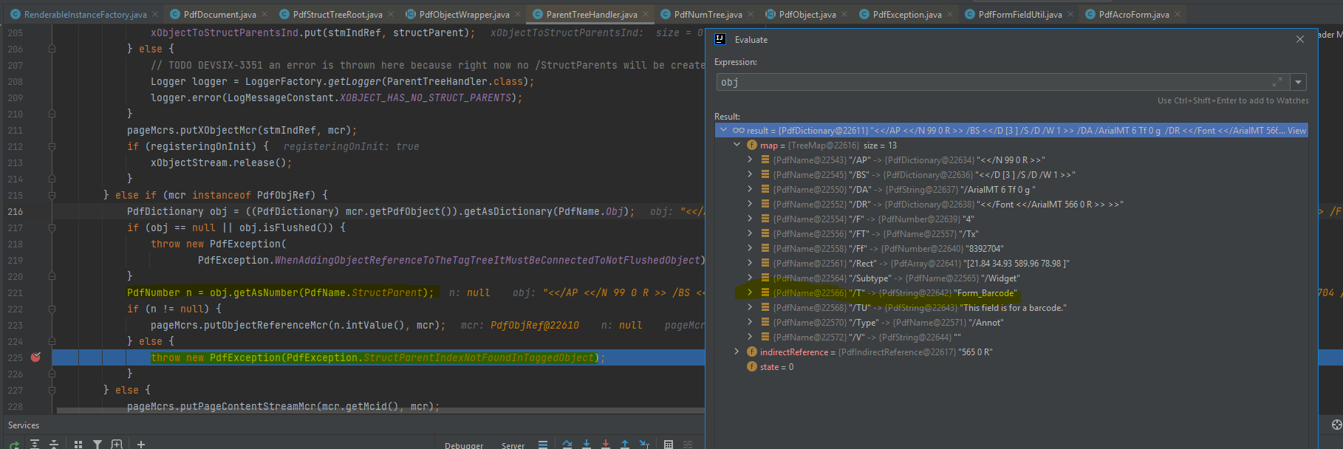

Treeset comes from SortedSet which comes from Set



Collctions Binary search





Same reference!

Changes on seatCopy will also impact theatre.seats

Map can remove by key/pair request



A **final class** cannot extended to create a subclass. All methods in a final class are implicitly final . Class String is an example of a final class.



SET doesn’t have a .get(index) method

Using custom objects in Sets you need to override the equals and hascode methods in order to make sure values duplicated aren’t allowed.



Any objects that are equal should have hashcode and hence be stored in the same bucket



Override equals is not enough, it needs also to override hashcode or it will not work





.getOrDefault, si no existe regresa el item en su lugar



JAVA FX

MVC pattern



Finally Will execute unless jvm crashes

Try with resources































Override run method and then run it with start method.













join







Waits for another thread to complete or 2 seconds what happends first

Local variables of a thread are stored in the thread stack (one per thread, not able to access other’s thread stack) but they both can access the heap (instance values are stored here)



Synchronized completed a method for a thread before giving access to another thread to it

It cant synchronized a constructor





















Thread Pools.

Executer service instead of new Thread, the argument says the top threads which are available

Submit method when we want to receive a response from a thread

If future.get() is called it will be frozen until the result is available





Fair lock

Tries to be first come first serve





Live lock

Similar to deadlock, but instead of being blocked, they are waiting for other to complete unable to make progress. Ex 2 threads giving resource to other, it is not blocked but will never progress





















Lambda expressions



Functional interface

Only 1 unimplemented method

Lambda variables must be final or effectively final.



















Regular expression starting with abcDeee only will be replaced because of the symbol

String.matches

Matches requires the whole of the string to match if not it will return false



Only replaces if the end matches ijkl99z using the reg exp $ at the end



Replace any a,e,i with X



Replace any a,e,I just in case they are followed by a F or j and replace it with a X



Change anything different than e or j for an X



Replace a,b,c,d,e,f and from 3,4,5,6,7,8 for an X



Replace any number for a X



Replace all non digits for a X



Replace all spaces, tabs and new lines in string for “”



Replace just \t



The {3} indicates the number of ocurrences the preceding character has to be to match



1 or more e to match



0 or more e to match











Field watch point takes a look to when that var is access or updated and stops there in the execution



Networking

Server



Client



Multithread server

Many clients then many threads needed (move code to a class which extends Thread)

UDP

More fast but it doesn’t guarantee everything its going to reached destination

Client



Server



Java 9 Modules



























